Performance Analysis Report – BlazeDemo (50 Users)

# 1. Test Summary

This performance test was conducted on the BlazeDemo flight booking application with 50 concurrent users, using Apache JMeter. The objective was to evaluate the application's responsiveness and stability under load, and identify any performance bottlenecks.

# 2. Test Configuration

- Application Under Test: https://www.blazedemo.com  
- Tool Used: Apache JMeter  
- Number of Users: 50  
- Ramp-Up Time: 5 seconds  
- Loop Count: 1  
- Listeners Used:  
 • View Results Tree  
 • Summary Report  
 • Aggregate Report  
 • Graph Results

# 3. Results Overview

- All assertions passed successfully (0 failed assertions).  
- Error Percentage: 0.00% (no failed requests).  
- Average Response Time: ~772 ms  
- Max Response Time: 2164 ms  
- Throughput: ~19.5/sec total  
- Deviation is moderate, showing some response variation toward the end.

# 4. Observations & Analysis

• System handled 50 users without errors or breakdowns.  
• All pages (Homepage, Search, Choose, Booking) were served under 1 second average.  
• A few samples spiked close to 2 seconds (max 2164 ms), but overall performance remained within expected SLA.  
• Deviation in response time increased toward the test end, indicating a few slightly delayed responses.  
• No functional issues were detected — all assertions passed.

# 5. Supporting Screenshots

Below are screenshots from JMeter listeners for visual analysis.

• View Results Tree

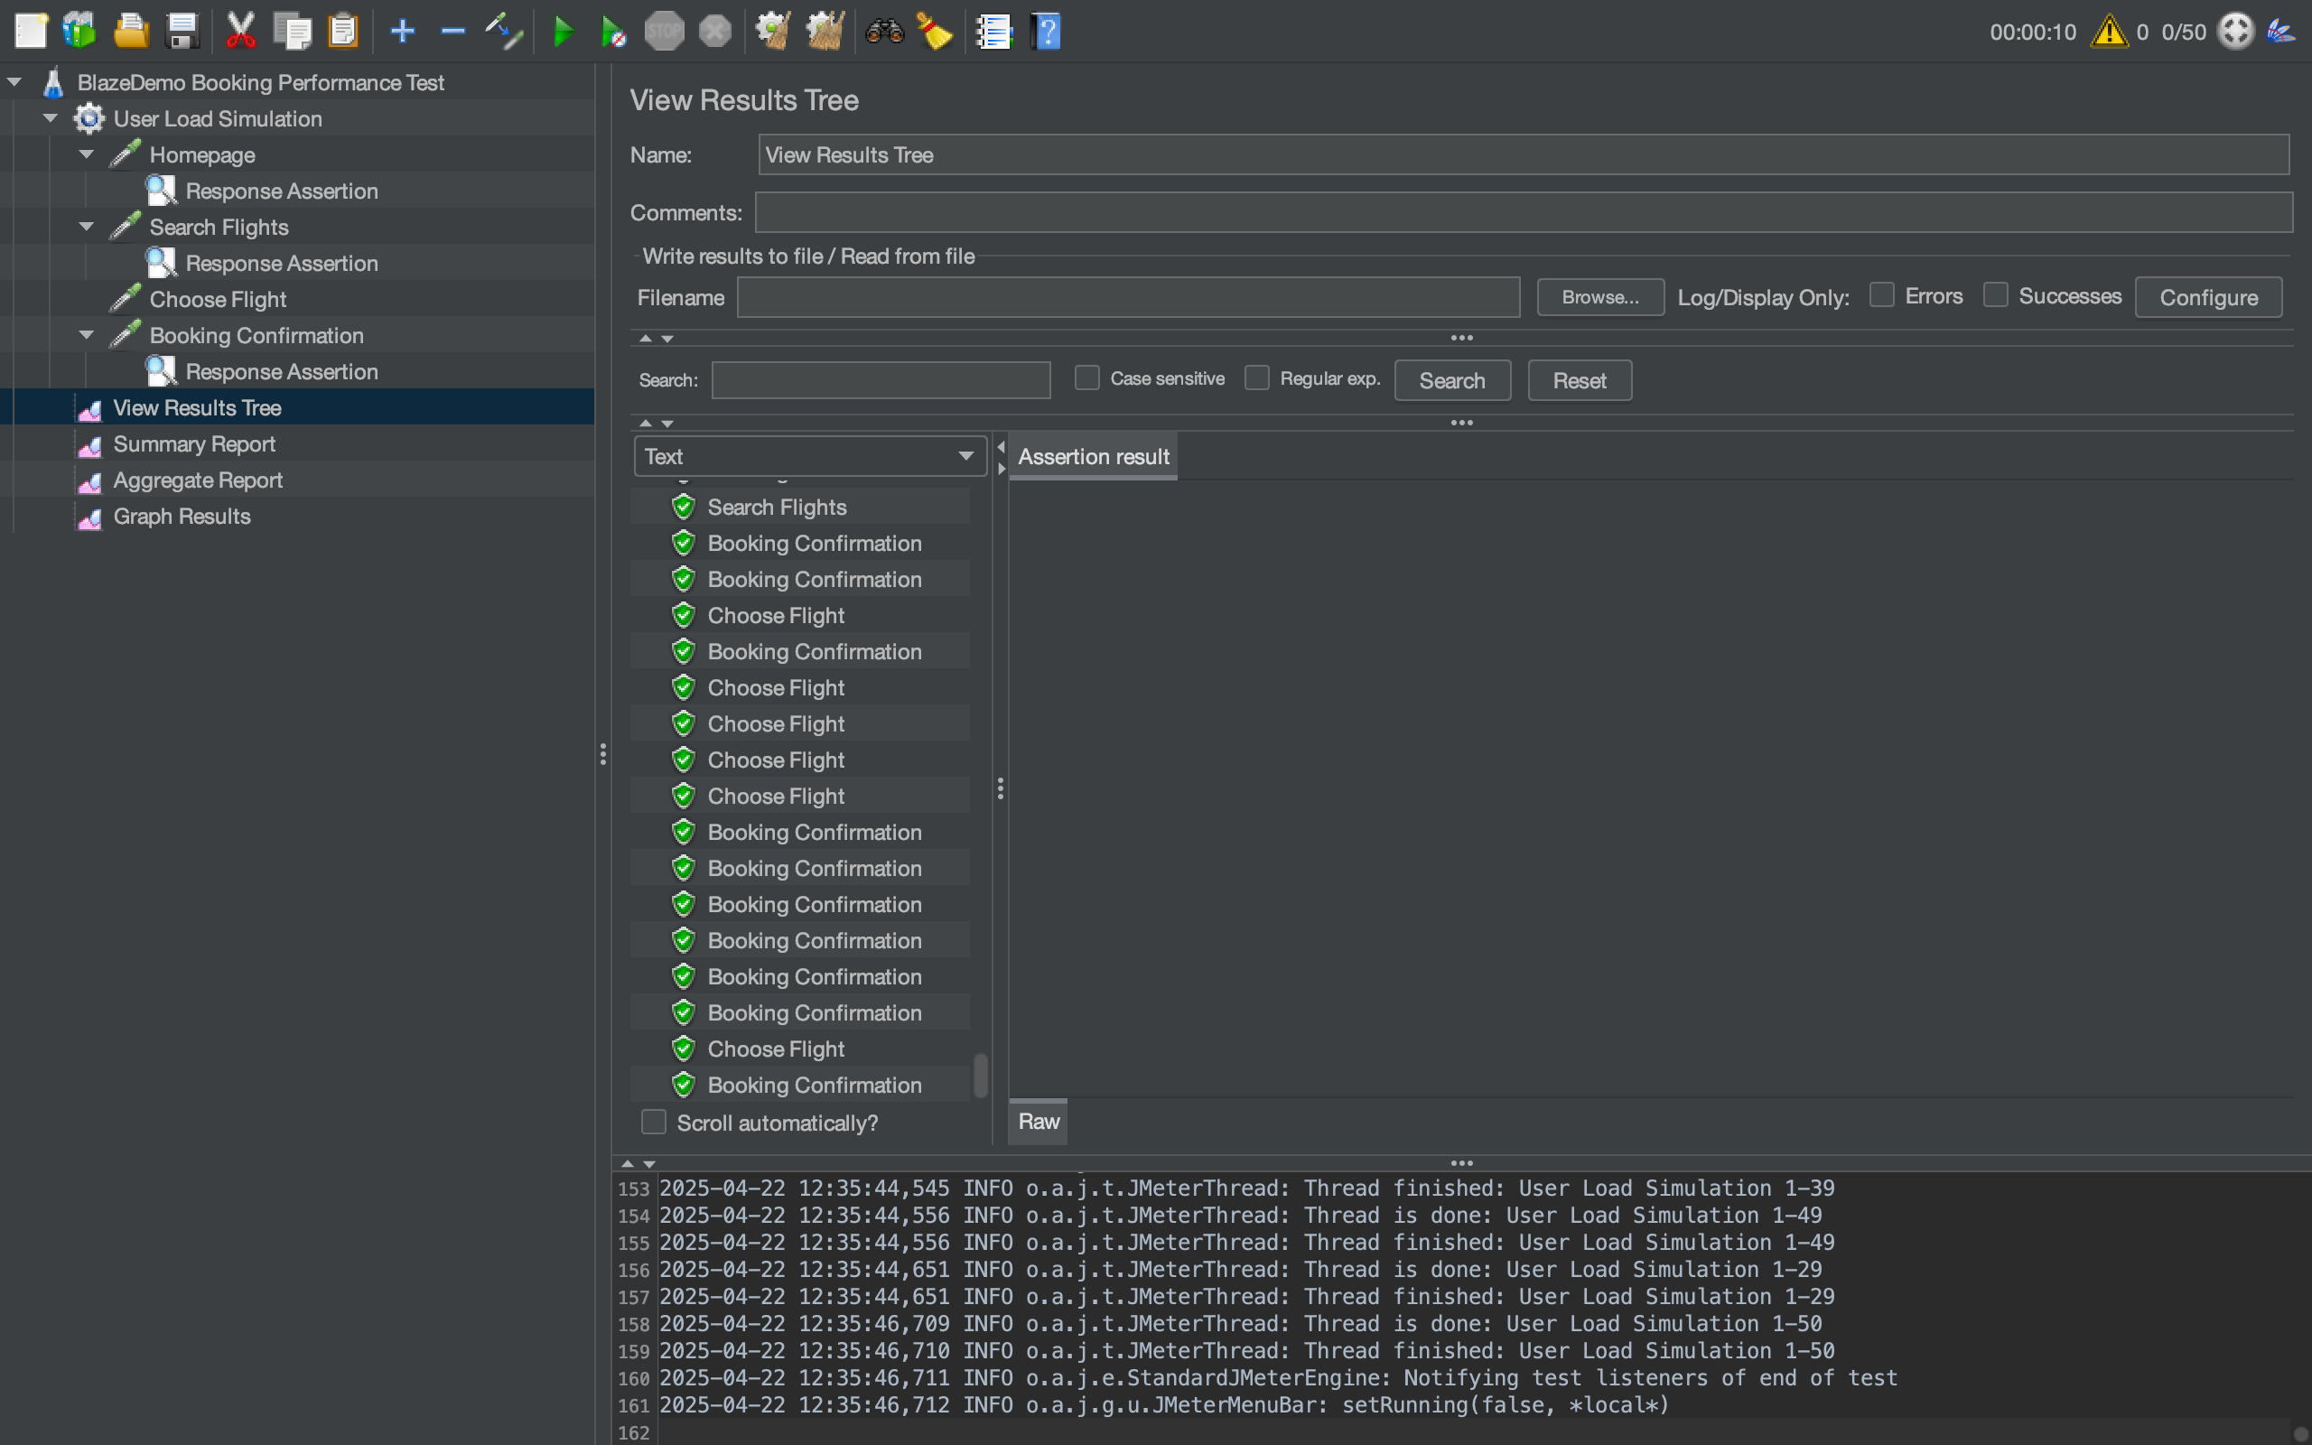

• Aggregate Report

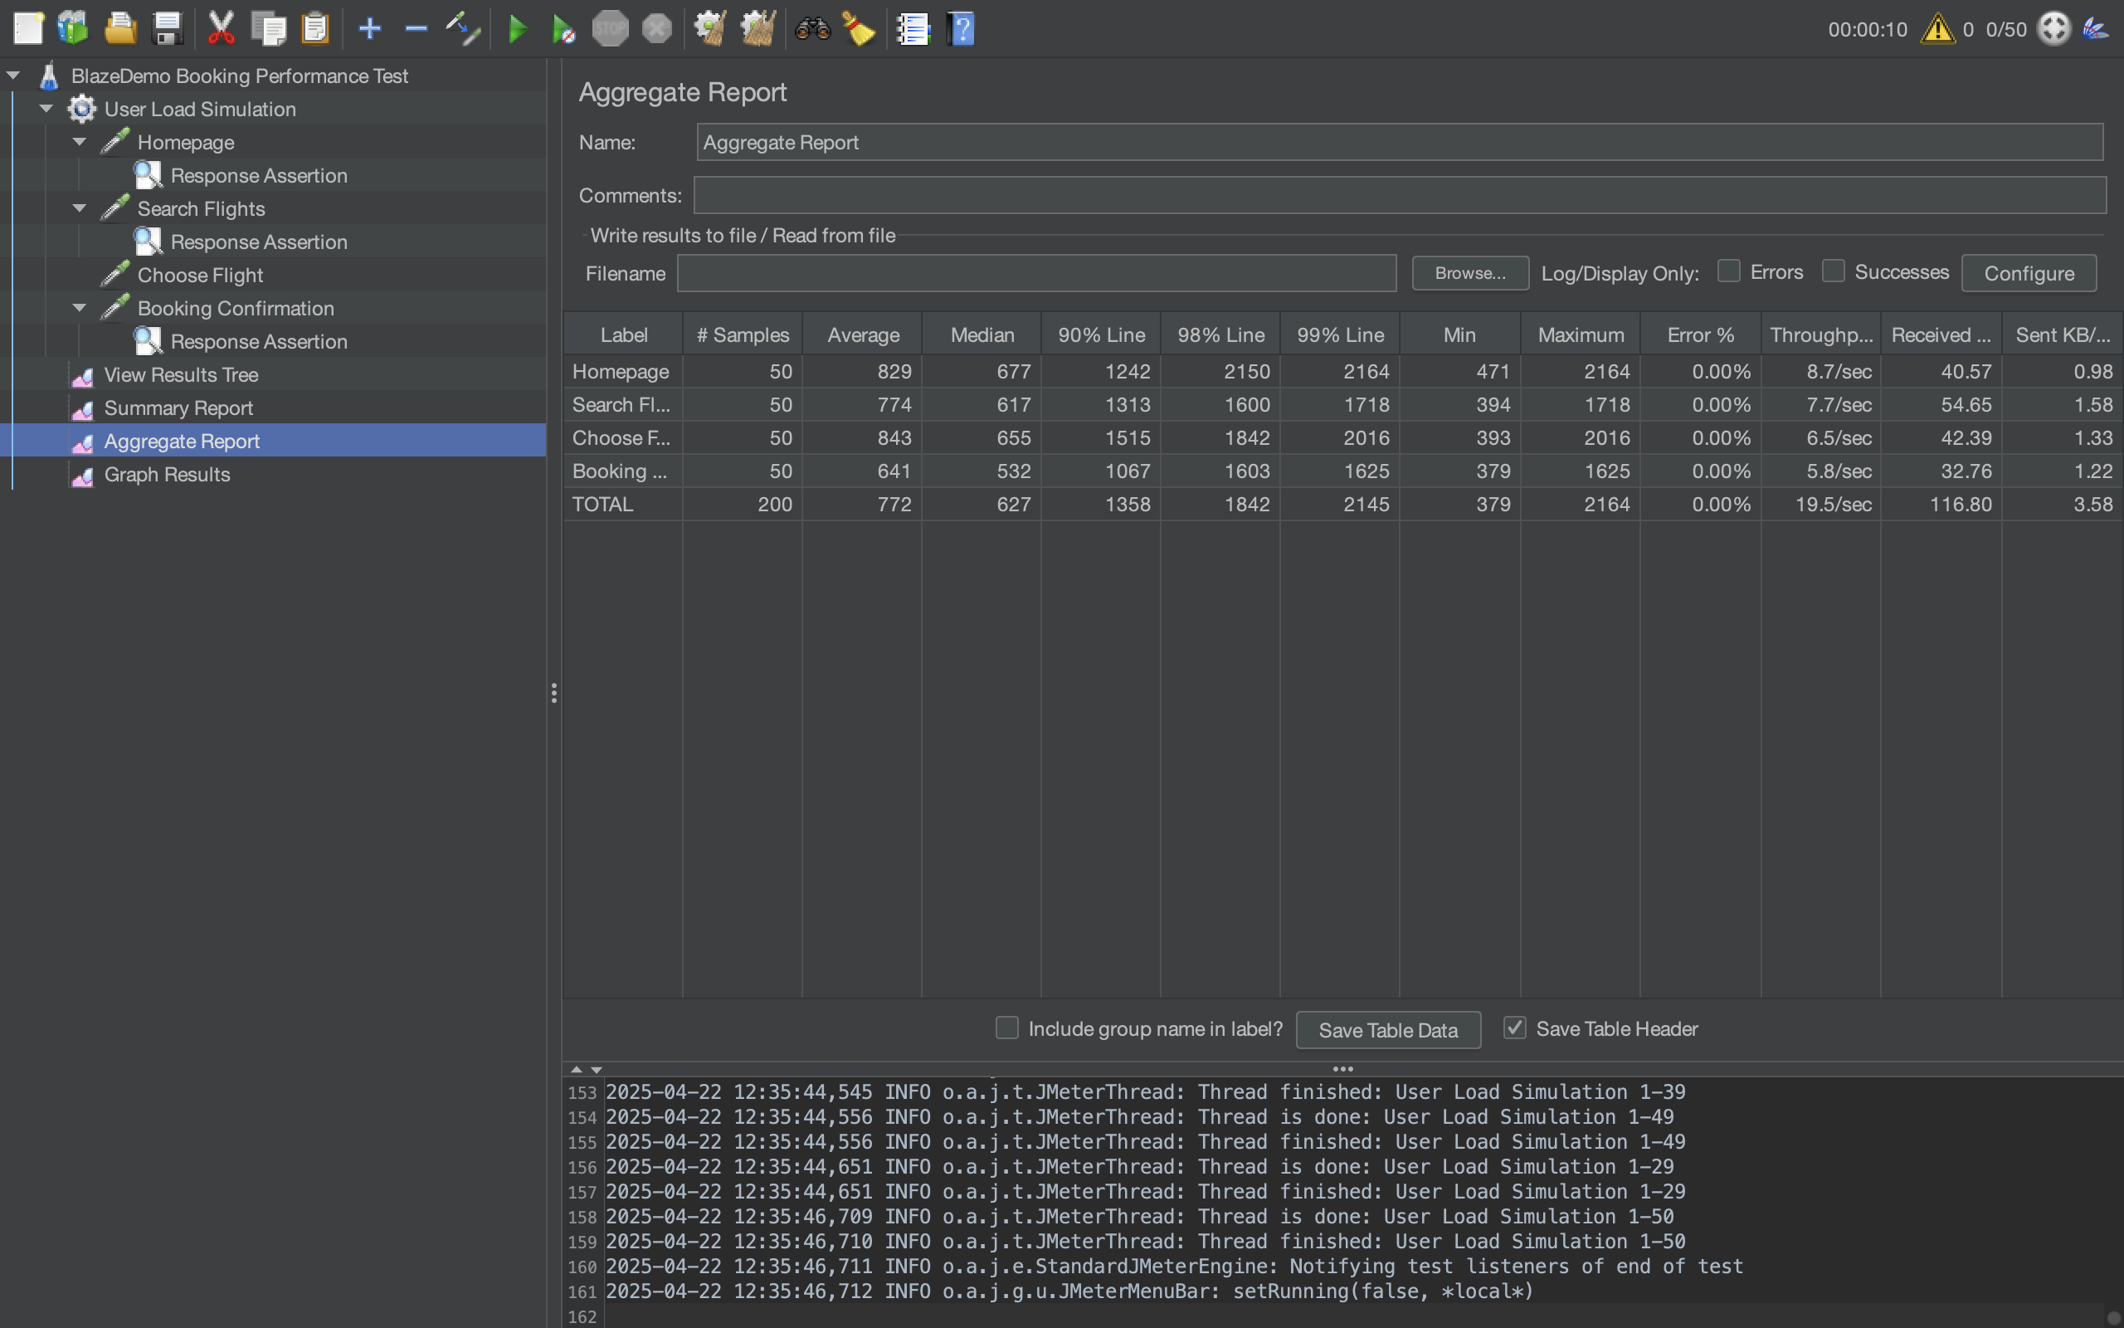

• Graph Results

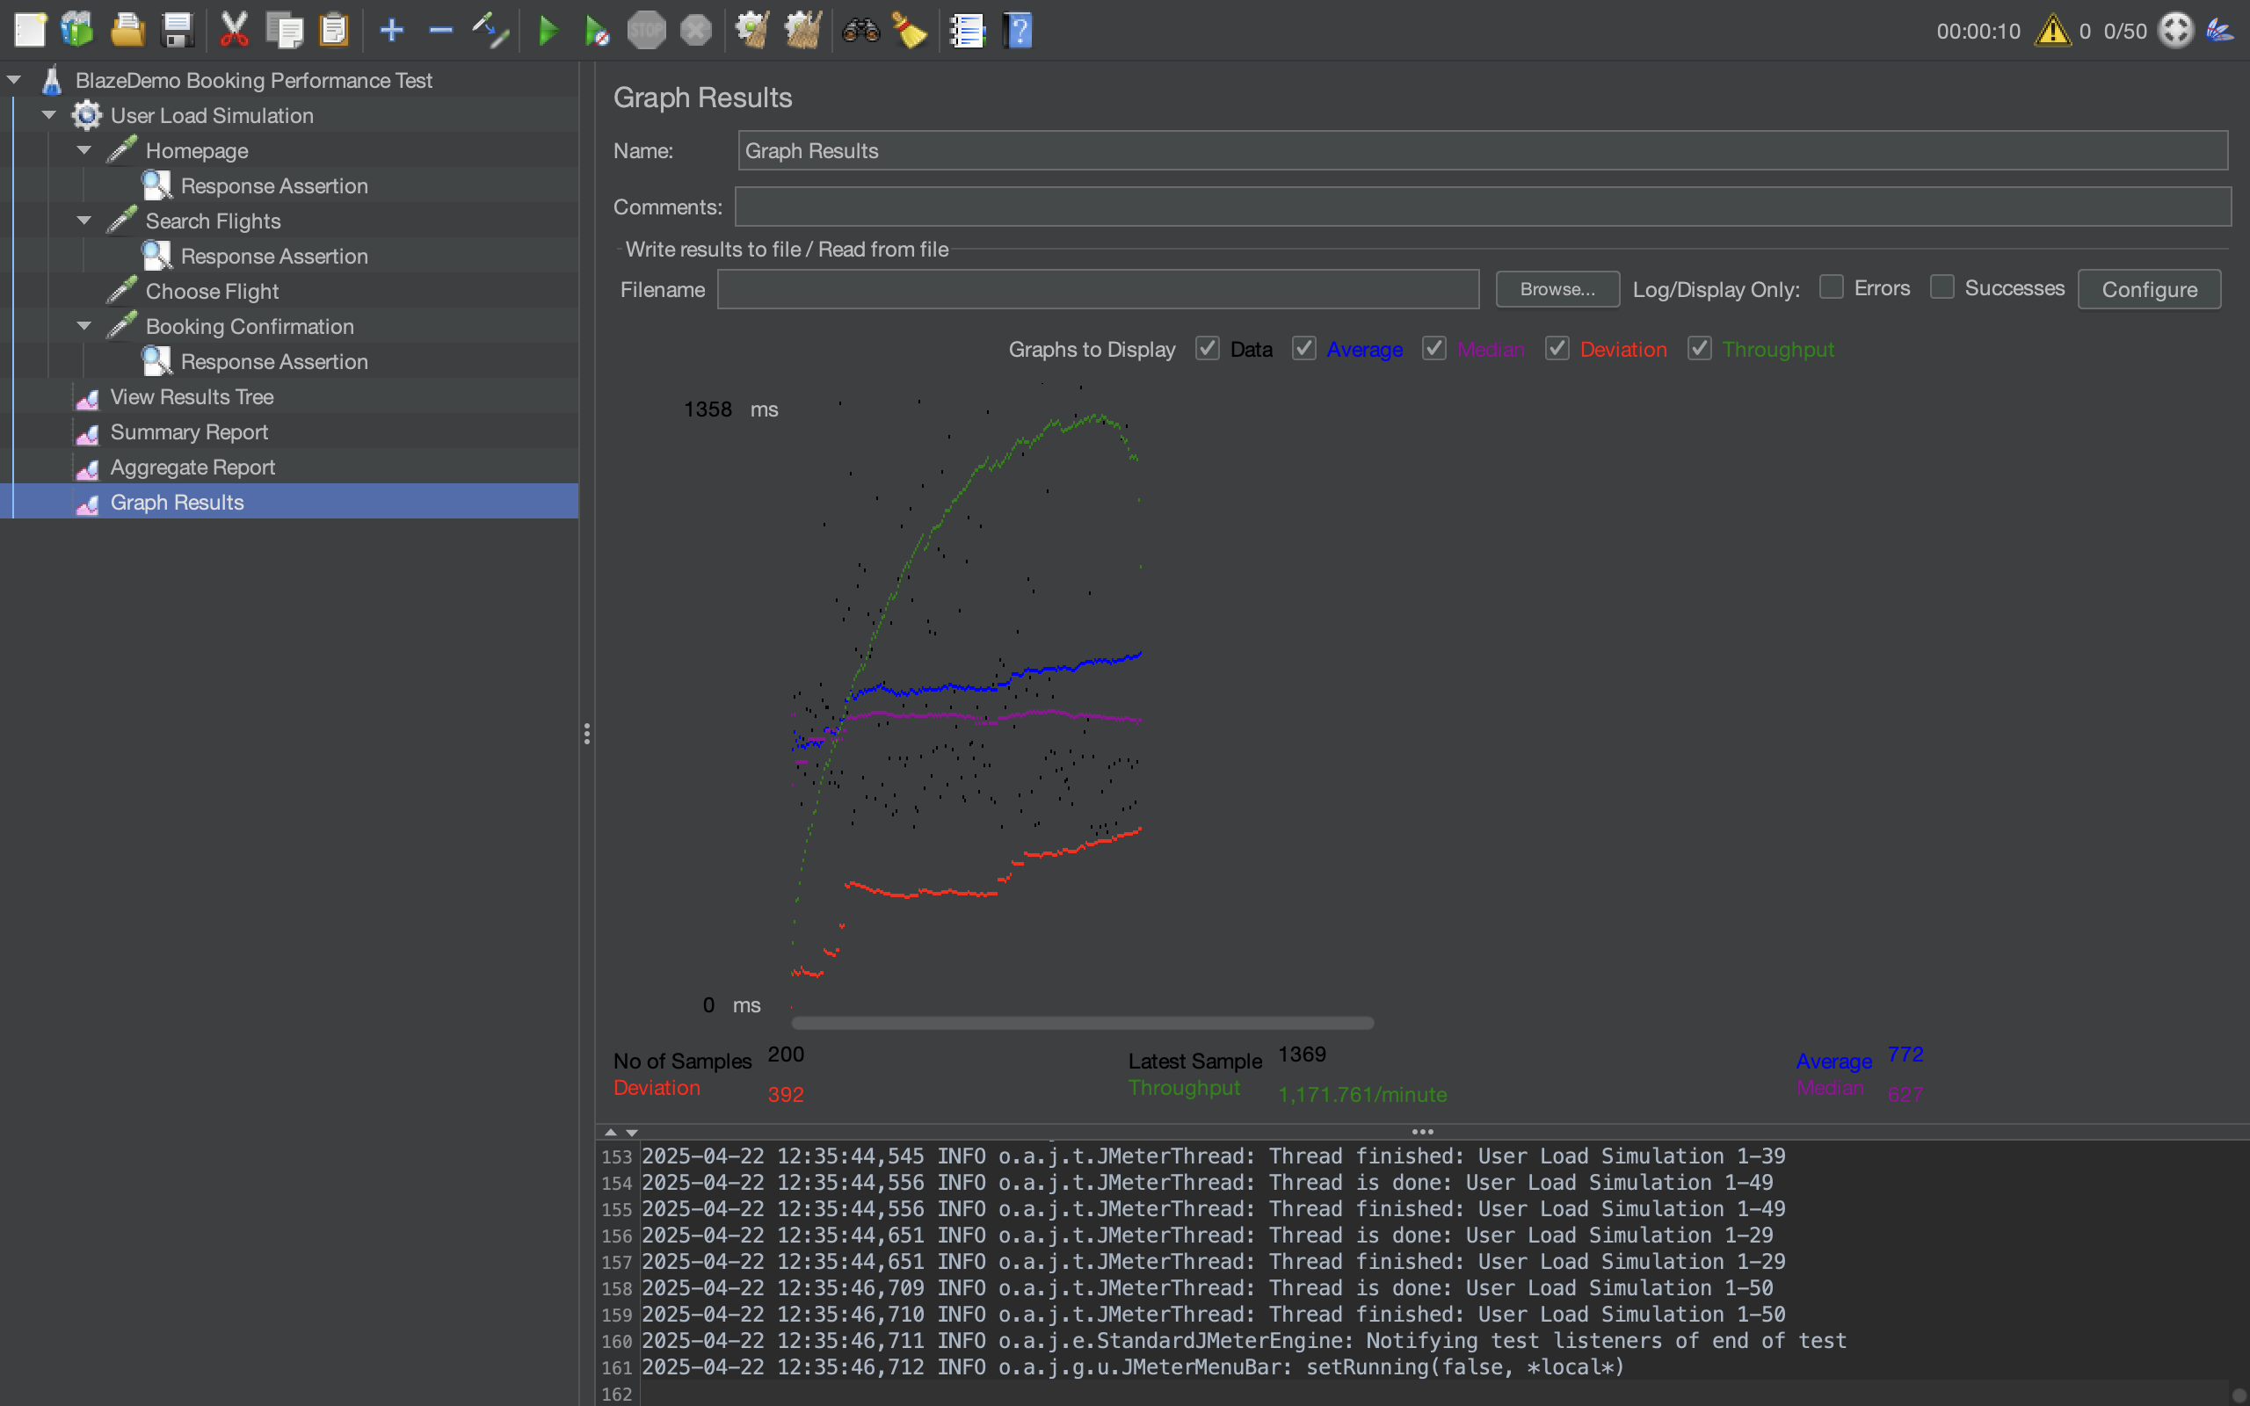

# 6. Conclusion

The BlazeDemo application demonstrated good performance under a load of 50 concurrent users. All critical transactions were completed successfully with zero errors. While some latency was observed at peak load, it remained within acceptable thresholds. The test validates the current system performance as stable.